Incident Report 12959: Create OWASP APP

Date: 5-23-2022 (DS)

# Executive Summary:

Using GitHub and Heroku, I was able to clone an app that will be useful for security trainings.

**Results**:

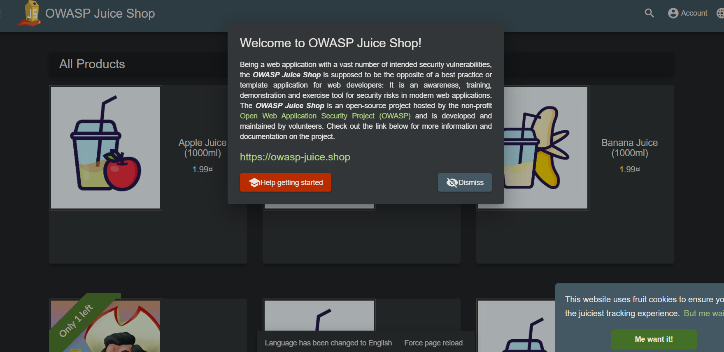

**Application Details:**

All steps were done on Google Chrome, using a repository on GitHub to deploy the app onto Heroku.

**Attack Narrative:**

No attacks or defensive incidents yet.

**Conclusion:**

The setup for this web program are complete and loaded successfully.

_____________________________________________________________________________________